

Optimization Techniques  
Group Assignment – Group 7

**Submitted by:**

Annapurna Garimella

Monalisa Mahato

Naveen Kumar Sambangi

Satish GVS

**Problem Statement:**

In the next six months a company must, in each month, operate either a normal shift or an extended shift (if it produces at all). A normal shift costs 100,000 per month and can produce up to 5,000 units per month. An extended shift costs 180,000 per month and can produce up to 7,500 units per month.

It is estimated that changing from a normal shift in one month to an extended shift in the next month costs an extra £15,000. No extra cost is incurred in changing from an extended shift in one month to a normal shift in the next month.

Carrying cost is estimated to be 2 per unit per month (based on the stock held at the end of each month) and the initial stock is 3,000 units (produced by a normal shift). At the end of month 6, at least 2000 units should be in stock. The demand for the company's product is shown below:

Month:   1 2 3 4 5 6

Demand:  6,000 6,500 7,500 7,000 6,000 6,000

IF the company produces anything in a particular month it must produce at least 2,000 units. If the company wants a production plan for the next six months that avoids stockouts, formulate their problem as an integer program.

Hint: first formulate the problem allowing non-linear constraints and then attempt to make all the constraints linear.

The decisions that have to be made relate to:

* Whether to operate a normal shift or an extended shift in each month?
* How much to produce each month?

**Introduction:** A general multi-period model aim is to optimize production cost, inventory and shift cost and the overall problem is formulated as an integer linear programming model by applying appropriate linearization’s of non-linear terms. The performance criterion is to minimize the cost.

**Steps to resolve the problem:**

**1)Decision Variables Description:** Below are theVariables used to solve the problem and the binary variables denotes as 1 🡪 Yes/Include and 0 🡪 No/Not to Include.

* Production Normal Shift Cost (N1, N2, N3, N4, N5, N6) – Binary Variables (1 or 0).
* Production Extended Shift Cost (E1, E2, E3, E4, E5, E6) – Binary Variable (1 or 0).
* Inventory Carrying Cost (I0, I1, I2, I3, I4, I5, I6) – Integer Variable
* Shift Exchange Cost (S1, S2, S3, S4, S5, S6) – Binary Variable (1 or 0)
* Production units (P1, P2, P3, P4, P5, P6) – Integer Variable
* Weighted production units (W1, W2, W3, W4, W5, W6) – Binary Variable (1 or 0).

**2)Objective function: Minimize the cost**

The objective is to minimize the cost, also need to find whether to operate a normal shift or an extended shift in each month and how much to produce in each month.

* Total production cost in Normal shift = 100000(N1+N2+N3+N4+N5+N6)
* Total production cost in Extended shift = 180000(E1+E2+E3+E4+E5+E6)
* Total Inventory Carrying Cost = 2(I1+I2+I3+I4+I5+I6)
* Total Shift Exchange Cost= 15000(S1+S2+S3+S4+S5+S6)

**Minimize Cost** = 100000(N1+N2+N3+N4+N5+N6) + 180000(E1+E2+E3+E4+E5+E6) + 2(I1+I2+I3+I4+I5+I6) + 15000(S1+S2+S3+S4+S5+S6).

**3)Constraints:** All the constraints are mention for the period of 6 months’ time period and the constraints of problem are below (t=1,2,3,4,5,6).

1. **Shift Constraints**: Only one shift should operate in each month (Nt+Et<=1).

|  |
| --- |
| N1+E1<=1 |
| N2+E2<=1 |
| N3+E3<=1 |
| N4+E4<=1 |
| N5+E5<=1 |
| N6+E6<=1 |

1. **Production Constraints**: Production limit should not exceed maximum capacity(5000Nt+7500Et>=Pt).

|  |
| --- |
| 5000*N1+7500*E1>=P1 |
| 5000*N2+7500*E2>=P2 |
| 5000*N3+7500*E3>=P3 |
| 5000*N4+7500*E4>=P4 |
| 5000*N5+7500*E5>=P5 |
| 5000*N6+7500*E6>=P6 |

1. Inventory, Production should not be negative (It>0, Pt>0).
2. For each period we have the following balance equation:

**Beginning Inventory+Production-Ending Inventory=Demand**

**Inventory Constraints:**

|  |
| --- |
| M1: P1 +3000-I1 = 6000 |
| M2: I1+P2 - I2 = 6500 |
| M3: I2 + P3 –I3 = 7500 |
| M4: I3+P4-I4 = 7000 |
| M5: I4 + P5 – I5 = 6000 |
| M6: I5 + P6-2000 = 6000 |

**Pictorial Way of Representation:** The relationship between production variables, inventory variables and the monthly demand over the 6-month horizon is represented below.

For i= 1,2,3,4,5,6 months

Number of units produced in month i = Pᵢ

Inventory units left at the end of month i = Iᵢ

The system starts with inventory I₀=3000 and ends with inventory I₆=2000.

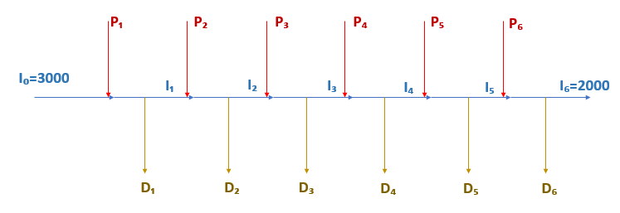

1. The amount of the stock at the end of the 6th month should be at least 2000 (I6>=2000).
2. If company produces anything in a particular month it must produce at least 2,000 units (2000Wt<=Pt).

|  |
| --- |
| 2000*W1<=P1 |
| 2000*W2<=P2 |
| 2000*W3<=P3 |
| 2000*W4<=P4 |
| 2000*W5<=P5 |
| 2000*W6<=P6 |

1. **Shift Cost Constraints:** Changing from a normal shift in one month to an extended shift in the next month (St=Nt*Et).

|  |
| --- |
| M1:S1=N0*E1 |
| M2: S2=N1*E2 |
| M3: S3=N2*E3 |
| M4: S4=N3*E4 |
| M5: S5=N4*E5 |
| M6: S6=N5*E6 |

**Solver Non-Linear Solution:**

**Objective Function:** Solverhas found the minimal cost as **€ 9,46,446** by using GRG non-linear method with all constraints are satisfied.

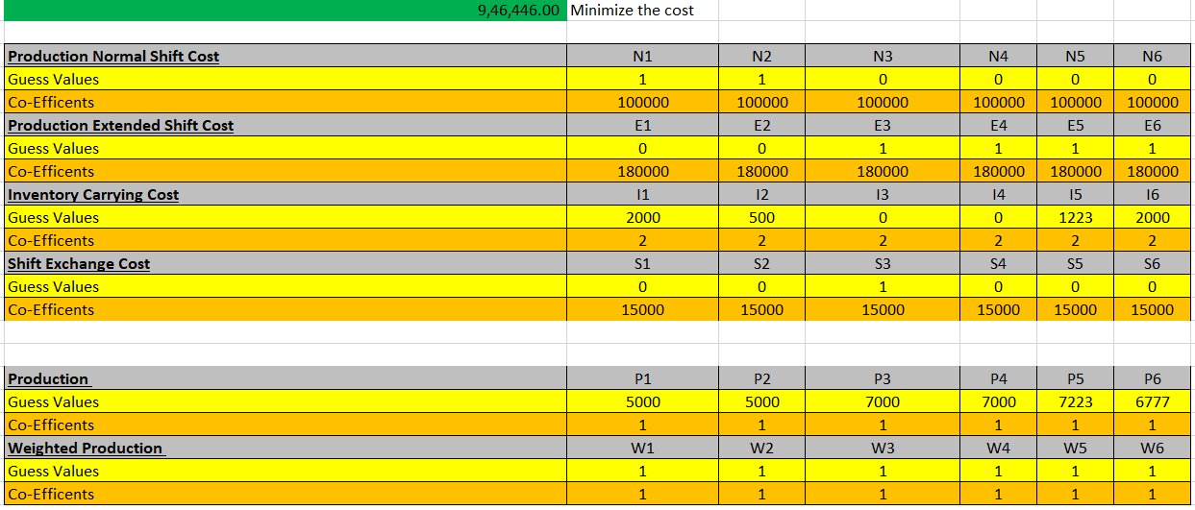

**Constraints:**

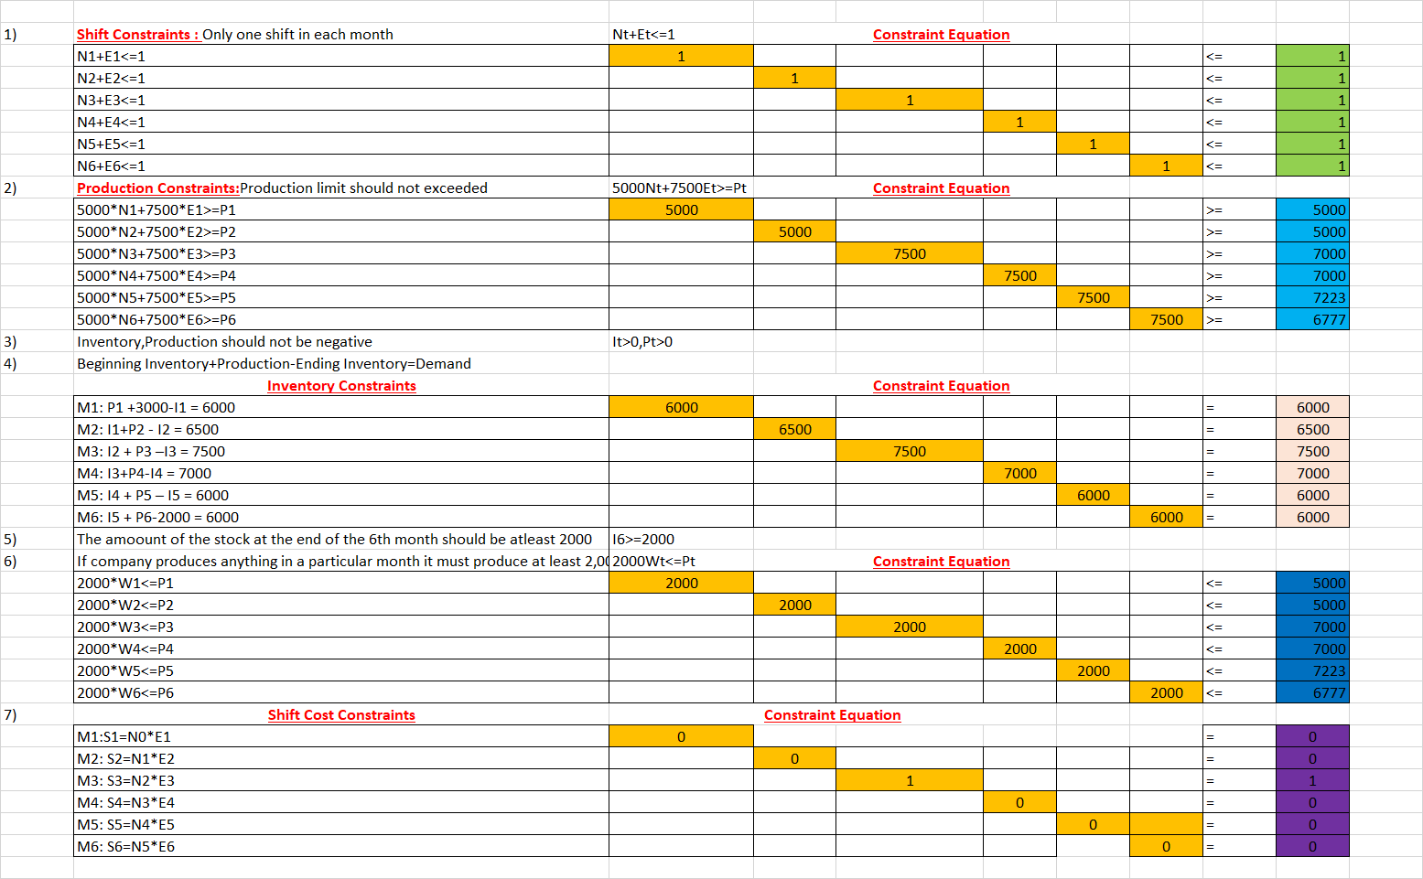

**Solver Non-Linear Answer Report:**

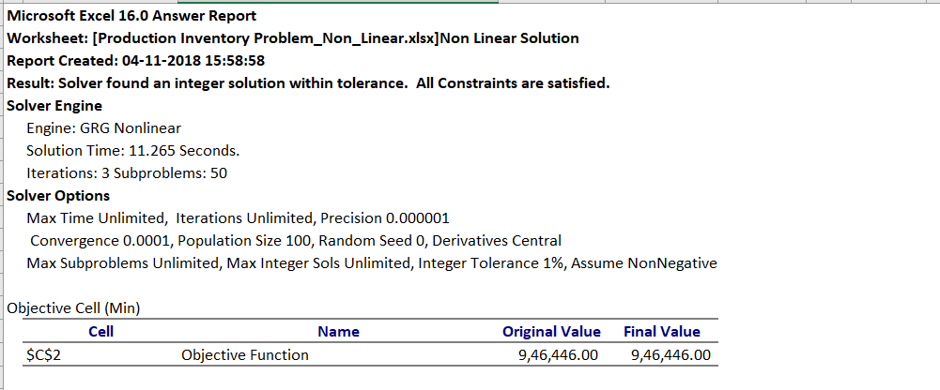

**Linearity Report:** Solver simplex LP unable to find the solution due the below constraints are violated.

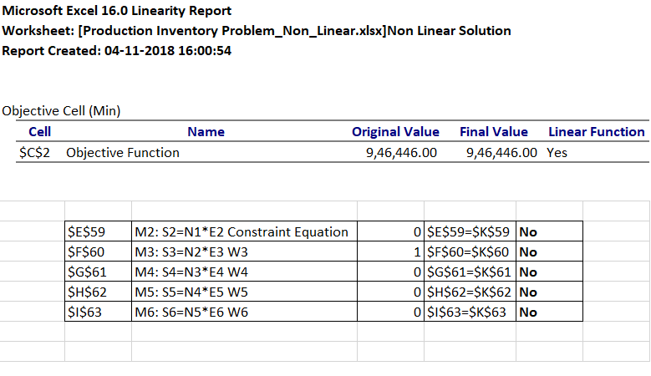

**Business Implications for Non-Linear Model:**

* The total associated cost is **€ 946,446** to the firm in order to run the business for next six months in different shifts.
* Normal shift is operated only for first two months.
* Extended shift is operated from third month to sixth month (total 4 months).
* It shows that demand for only 3rd and 4th months are satisfied from the same month’s production which indicates that the inventory for these months is Zero.
* Inventory carried out after end of first month is 2000 units, second month is 500 units, fifth month is 1223 units and sixth month is 2000(which is required).
* Shift exchange cost is required only once i.e. at end of second month. So, the shift exchange cost is included in third month total cost.
* Weighted production is required in all months.
* Number of units to produce for respective months are:

|  |  |
| --- | --- |
| **Month** | **Production Units** |
| First | P1=5000 |
| Second | P2=5000 |
| Third | P3=7000 |
| Fourth | P4=7000 |
| Fifth | P5=7223 |
| Sixth | P6=6777 |

**Pictorial Representation of Non-Linear Solution:**

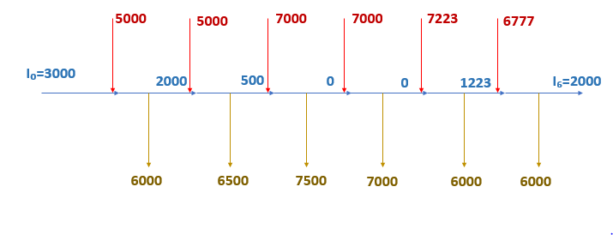

**4) Converting Non-Linear Constraints to Linear Constraints:** As solver unable to find the solution to the problem by using **simplex LP method** hence, we need to convert the above non-linear constraints into linear constraints.

The Non-linear constraint St=Nt*Et can be converted into the below two linear constraints.

**St <= (Nt-1 + Et)/2 t=1, 2,3,4,5,6 and St >= Nt-1 + Et - 1 t=1, 2,3,4,5,6**

Making the above change the constraints has transfer from non-linear integer program given before into an equivalent linear integer program.

**Solver Linear Solution:**

**Objective Function:** Solverhas found the minimal cost as **€ 9,43,000** by using Simplex linear method with all constraints are satisfied.

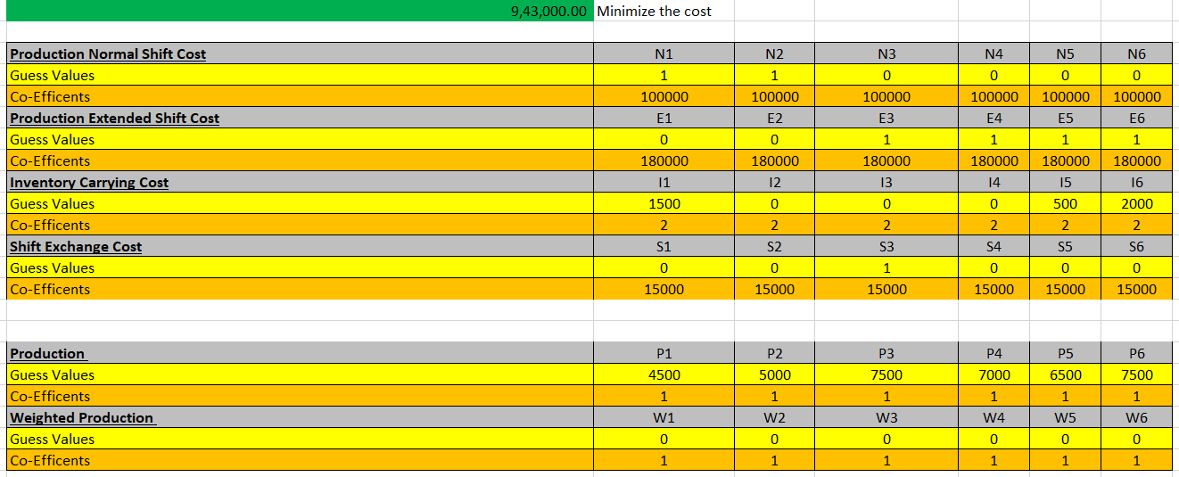

**Constraints: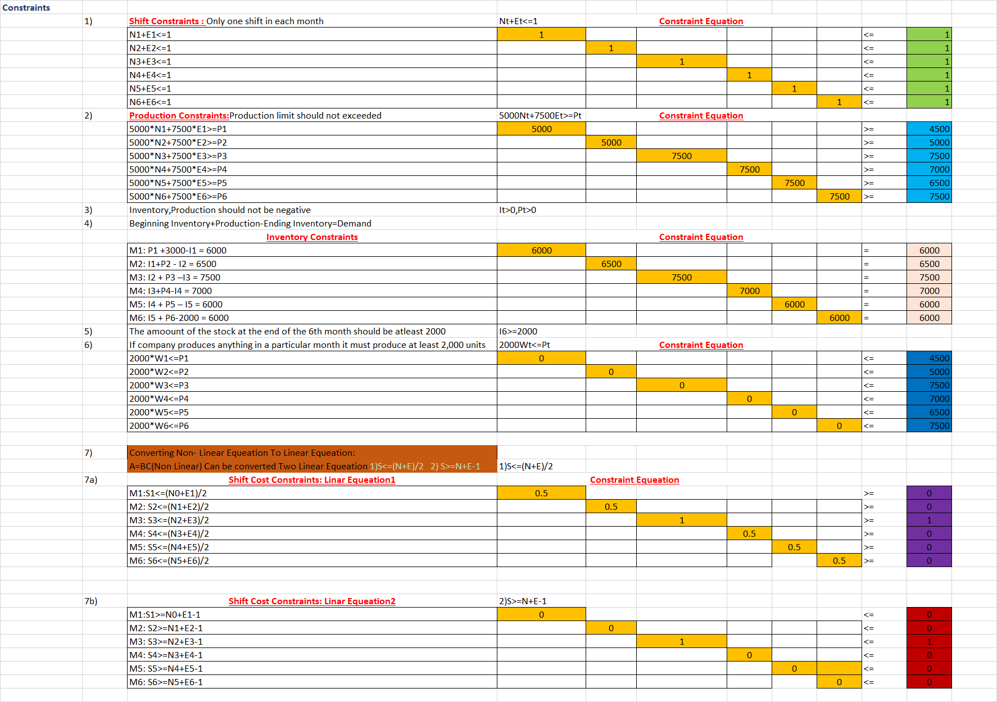Solver Linear Answer Report:**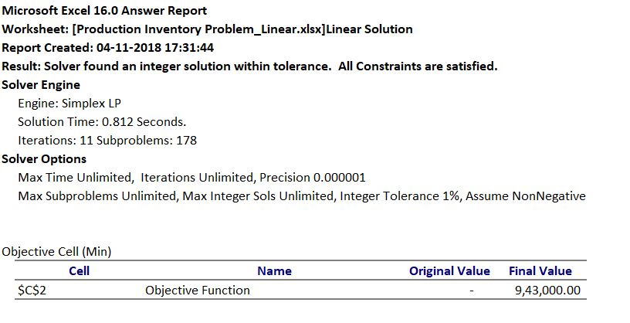

**Business Implications for Linear Model:**

* The total associated cost is **€ 9,43,000** to the firm in order to run the business for next six months in different shifts.
* Normal shift is operated only for first two months.
* Extended shift is operated from third month to sixth month (total 4 months).
* It shows that demand for only **2nd,3rd and 4th** months are satisfied from the same month’s production which indicates that the inventory for these months is Zero.
* Inventory carried out after end of first month is 1500 units, fifth month is 500 units and sixth month is 2000(which is required).
* Shift exchange cost is required only once i.e. at end of second month. So, the shift exchange cost is included in third month total cost.
* Weighted production is required in all months.
* Number of units to produce for respective months are:

|  |  |
| --- | --- |
| **Month** | **Production Units** |
| First | P1=4500 |
| Second | P2=5000 |
| Third | P3=7500 |
| Fourth | P4=7000 |
| Fifth | P5=6500 |
| Sixth | P6=7500 |

**Pictorial Representation of Linear Solution:**

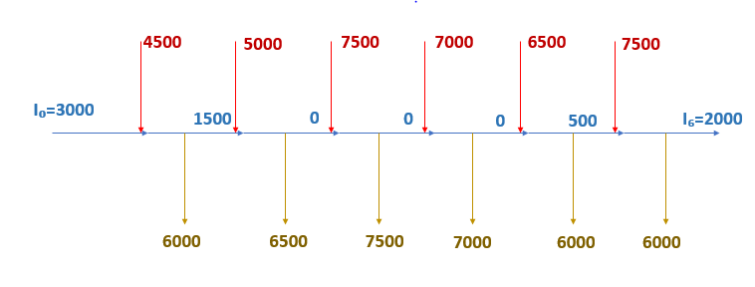

**Non-Linear and Linear Solution Excels:**



**5)Conclusion:**

The cost obtained from linear solution is less compared to the non-linear solution this is due to local and global minimal problem, hence we can choose the linear model to implement the plan for the next six months of the firm**.**